HOW TO CONSENT FOR YOUR CHILD TO HAVE A VACCINATION
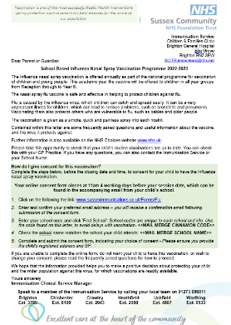
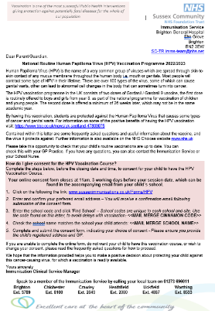
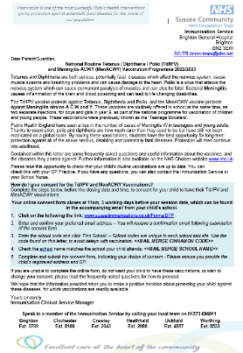
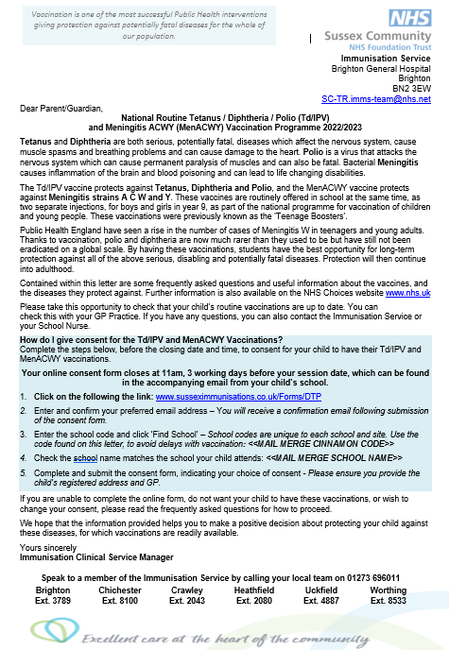
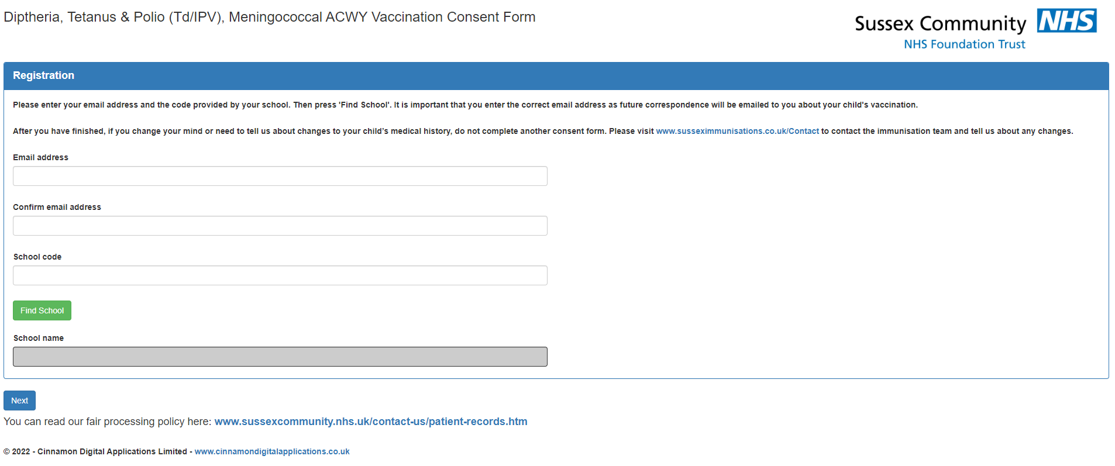
THE FIRST SCREEN WILL LOOK LIKE THIS.
To consent for the Tetanus / Diphtheria / Polio and Meningitis ACWY Vaccinations, use this link:
www.susseximmunisations.co.uk/Forms/DTP
To consent for Flu Vaccination, use this link:
www.susseximmunisations.co.uk/Forms/Flu
To consent for both doses of HPV Vaccination, use this link:
www.susseximmunisations.co.uk/Forms/HPV
Make sure this vaccination name matches the one at the top of your parent consent letter.
It will tell you at the top of the screen which consent form you have opened.
YOU WILL NEED THE PARENT CONSENT LETTER YOUR CHILDS SCHOOL SENT YOU FOR THIS SCREEN.
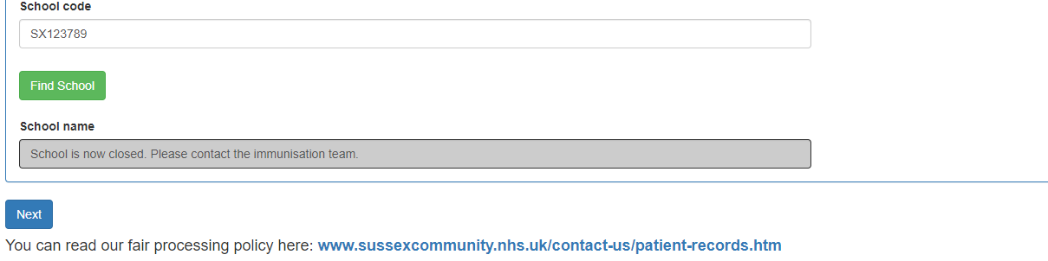
Is the school name correct?

If yes, click next.
If no, recheck the code on the parent letter (make sure any 0’s are entered as a number not a letter).

For assistance call one of the numbers on the bottom of the parent letter.
Check the school name in the grey box matches the school name on your parent consent letter – this is in the coloured box.
Enter your school code – this is on your parent consent letter in the coloured box.
Enter your email address into both these boxes.
THE NEXT SCREEN LOOKS LIKE THIS.
IT HAS BOXES TO WRITE YOUR CHILDS NAME, DATE OF BIRTH AND GP SURGERY.
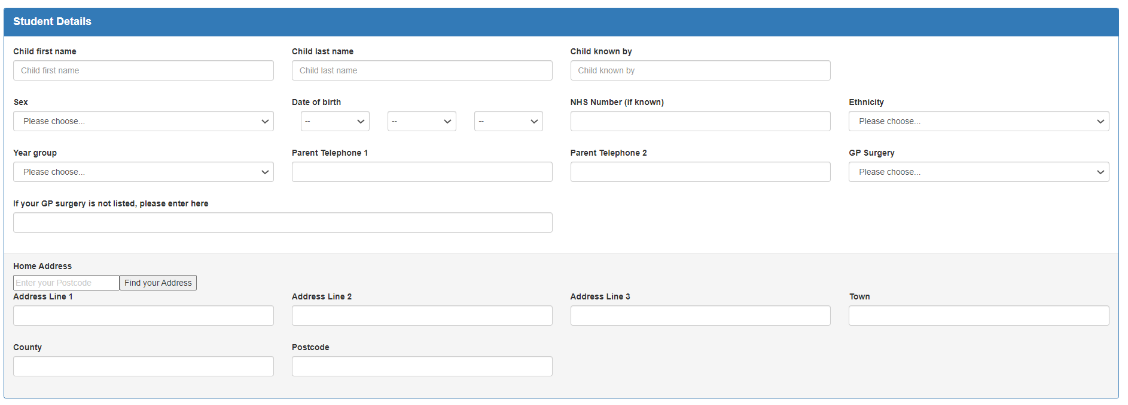
Click ‘Next’ to go to the next screen once you have completed the boxes.
Tell us your childs address by writing the postcode in this box. Click the ‘find your address’ button

Do you call your child something different at home? i.e is their name Christopher, but you call them Chris? If yes, write the name in this box. Leave it blank if not.
Select your childs address from the drop-down list
Don’t worry if you don’t know your childs NHS number, you can leave this box blank.
Click on the drop-down arrows, circled here in red, to help you complete the other boxes.
You need to write your childs first name and last name in these boxes.
THE NEXT SCREEN LOOKS LIKE THIS (for flu, this will be after the screen on the next page)
IT ASKS QUESTIONS ABOUT YOUR CHILD’S MEDICAL HISTORY.
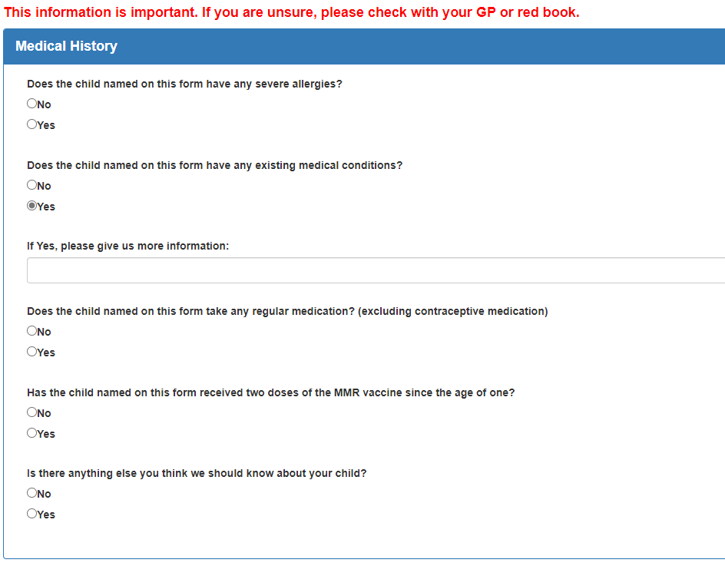
Click ‘Next’ to go to the next screen once you have completed the boxes.
Click in the circle next to your answer for each question.
If you answer ‘Yes’ to any of the questions, this box will pop up…
You need to give more information in this box. i.e. Write the name and details of your childs medical condition.
THIS IS THE LAST SCREEN (for flu it is the second to last screen).
THE FIRST QUESTION ASKS YOU IF YOU CONSENT FOR VACCINATION.
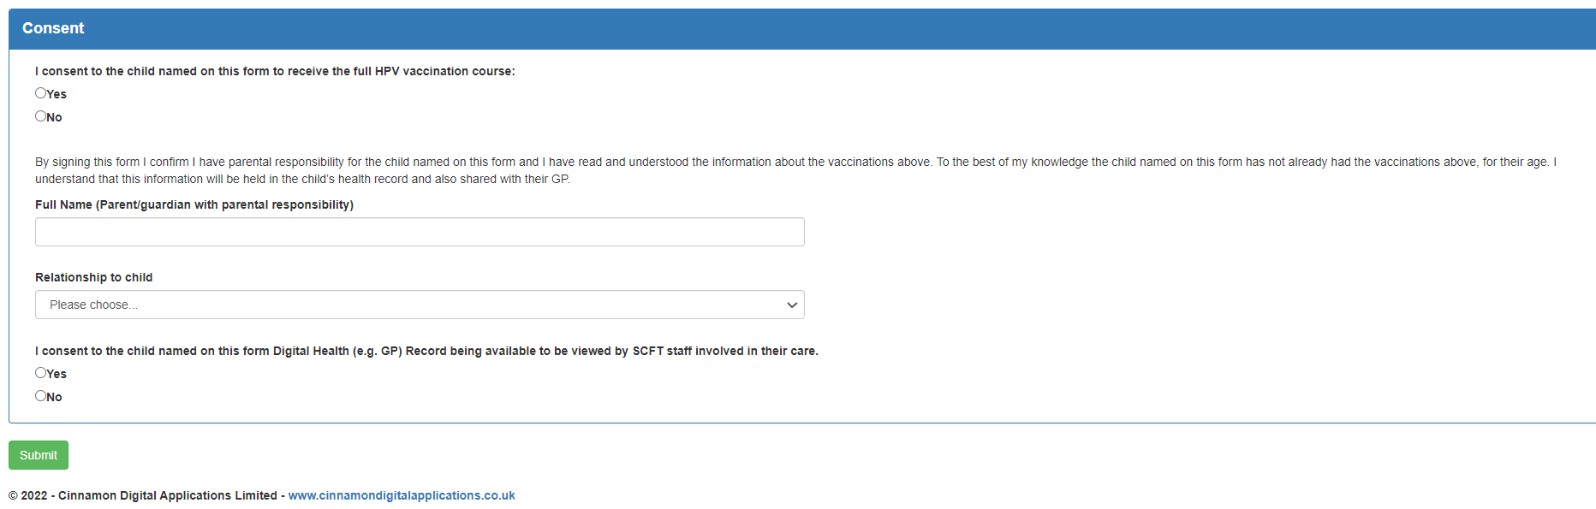
Click in the circle next to your answer.
Click in the circle next to your answer.
Click ‘Submit’ to send us your completed form.
Use the drop-down list to tell us who you are. i.e. Mother.
Write your name in this box.
Use the drop-down list to pick a reason.
If you select ‘No’ this box will appear
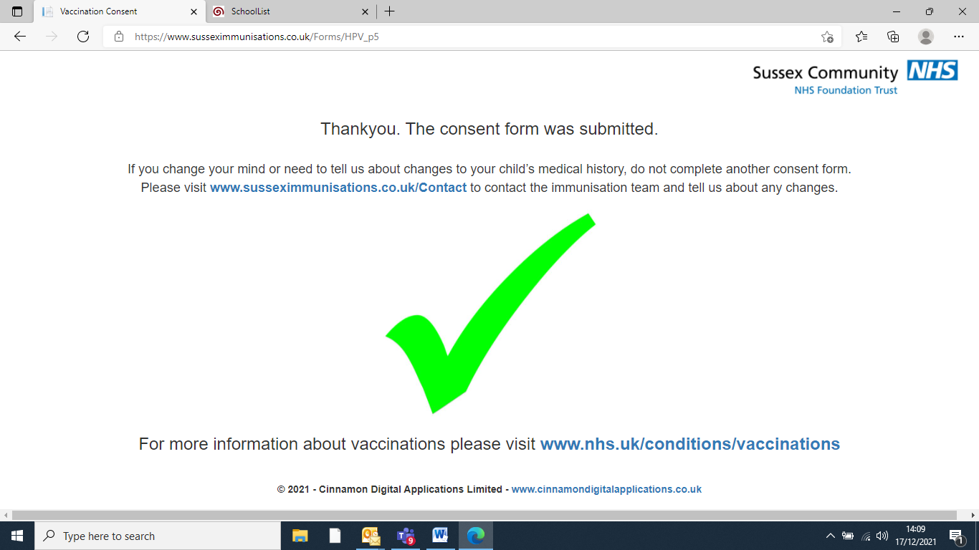
WHEN YOU CLICK THE GREEN SUBMIT BUTTOM THIS PAGE WILL APPEAR.
YOU WILL ALSO GET AN EMAIL TELLING YOU A CONSENT FORM HAS BEEN SUBMITTED FOR YOUR CHILD.
If you need additional support, please call us:
01273 696011
EXT.
Brighton – 3789
Crawley – 2043
Heathfield – 2080
Worthing – 8533
Chichester – 8100
Uckfield - 4783

