April 2022
Dear Parents/Guardians,

Year 5 - Residential School Trip to PGL Adventure 2022
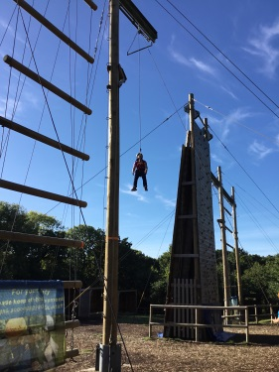
Exciting news, the current year 4s will be going on a PGL trip this September! It will take place at Little Canada Activity Centre on the Isle of Wight. Every pupil in year 5 participates (excluding those with exceptional circumstances) as we regard this trip to be a valuable part of your child’s development. As well as being great fun, this trip will also teach the children a number of important life skills including: teambuilding, self-confidence, trust, bravery and communication. This will be our ninth annual trip to PGL and will give both existing and new pupils the opportunity to get to know each other a lot better, form those all-important friendships and bring the year group together as one.

Dates
Depart: Friday 16th September 2022 (leaving Windlesham at approximately 10.00am)
Return: Monday 19th September 2022 (returning by 3.30pm)

About PGL
PGL has been introducing outdoor activities to children since 1957. There are 35 PGL Centres in Britain, France and Spain offering the widest range of courses available to schools. Their proven record is the reason why we are choosing them to provide our activity course. There are also various videos on YouTube you can watch which give you further information about PGL.

Little Canada, Fishbourne, Isle of Wight
On the Isle of Wight, minutes from the Fishbourne Ferry, Little Canada is located in 48 acres of beautiful woodland on the banks of Wootton Creek. The centre offers distinctive log cabin style accommodation and a diverse range of indoor and outdoor activities. The PGL staff at Little Canada are specially selected for their excellent skills with primary aged children.

Accommodation
We will be staying in Log Cabins. Rooms sleep between 4 – 8 children and have en-suite facilities. Windlesham House staff will also be accommodated in single rooms next to the cabins to ensure everyone gets to sleep at a reasonable time.

Activities
There are numerous activities available including abseiling, trapeze, dragon boating, zip wire, high ropes course, tunnel trail, muddy assault course, archery, rock climbing, quad bikes and many more.
Cost
The total cost of this trip will be approximately £250.00. This price includes transport, ferry crossing, accommodation, a trip to Monkey Haven, food, full activity programme, insurance and a hoody. The charge will be added to your school bill in the spring term 2023.
COVID-19
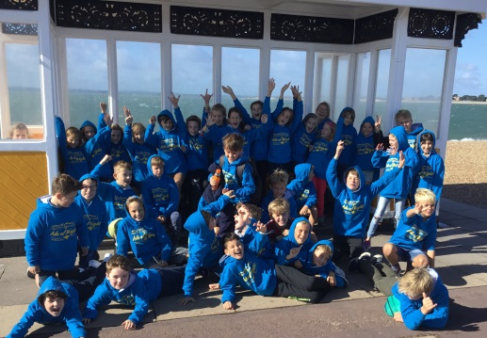
The school in, conjunction with PGL, will adhere to any government guidelines in relation to COVID protocols.
And Finally…
This really is a wonderful opportunity for your child to participate in a number of outward-bound activities in a safe and secure environment. Being away from the comfort of home can be quite unsettling (for children and parents!). Going on a school residential trip with your friends and teachers can make this experience far less worrying.
If you have any further queries, please do not hesitate to contact me scharman@windlesham.com
Yours sincerely,
Stacey Charman
-----------------------------------------------------------------------------------------------------------
F.A.O. Miss S. Charman, Windlesham House School, Washington, Pulborough, West Sussex RH20 4AY

Year 5 PGL Adventure Holiday 2022
Name: …………………………………………………
would like to go on the PGL Adventure Holiday: Friday 16th – Monday 19th September 2022
I agree for the cost of the holiday, approximately £250.00, to be added to my Windlesham House account.
Parent/Guardian……………………………………………………..…….. Date………………………………………….………
Signature……………………………………………………..……………….
Please return this slip as soon as possible.

